dict1={'Name':'Zara','Age':7,'Class':'First','Name':'Trng'}

print(type(dict1))

print(dict1)

print("keys",dict1.keys())

print("values",dict1.values())

print("items",dict1.items())

print("dict['Name']:",dict1['Name'])

print("dict['Age']:",dict1['Age'])

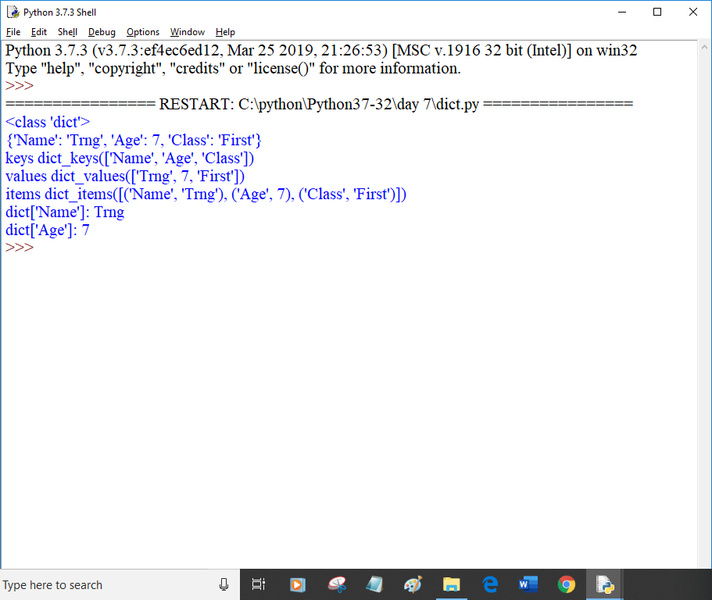

def printblue():

print('You chose blue:''\n')

return

def printred():

print('You chose red:''\n')

return

def printorange():

print('You chose orange:''\n')

return

def printyellow():

print('You chose yellow:''\n')

return

def choice():

print("0: blue")

print("1: red")

print("2: orange")

print("3: yellow")

print("4:Quit")

return

colorselect={0:printblue,1:printred, 2:printorange, 3:printyellow}

selection=0

while True:

if selection == 4:

break

choice()

selection=int(input("Select a color option:"))

if (selection>=0) and (selection<4):

colorselect[selection]()

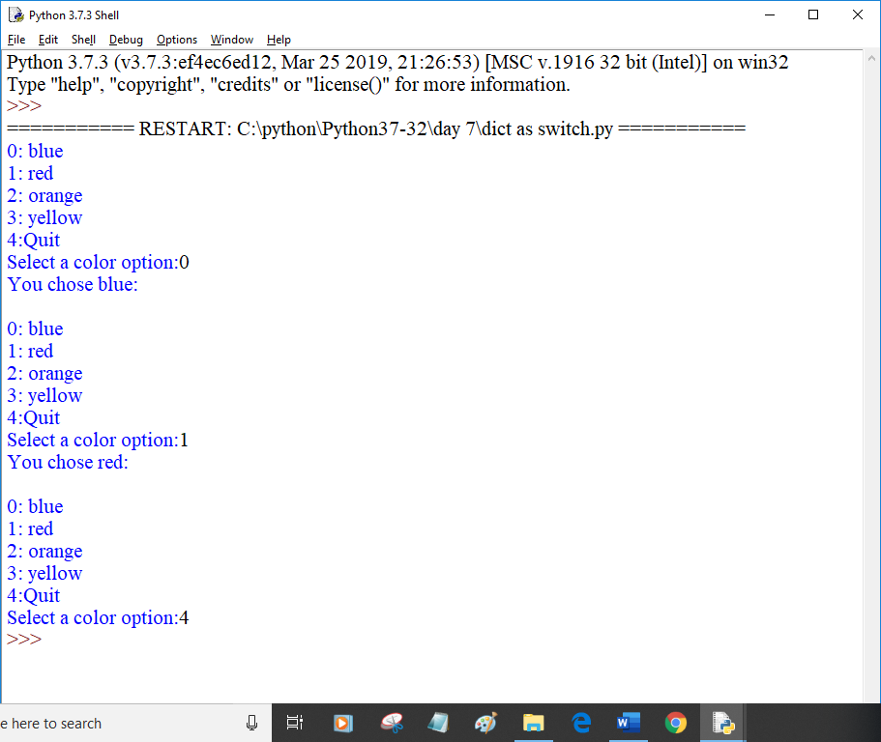

def kelvintofahrenheit(temperature):

assert(temperature>=0),"Colder than absolute zero!"

res=((temperature-273)\*1.8)+32

return res

try:

print(kelvintofahrenheit(273))

print(kelvintofahrenheit(505.78))

print(kelvintofahrenheit(-5))

except AssertionError as ob:

print(ob)

print("Thank You")

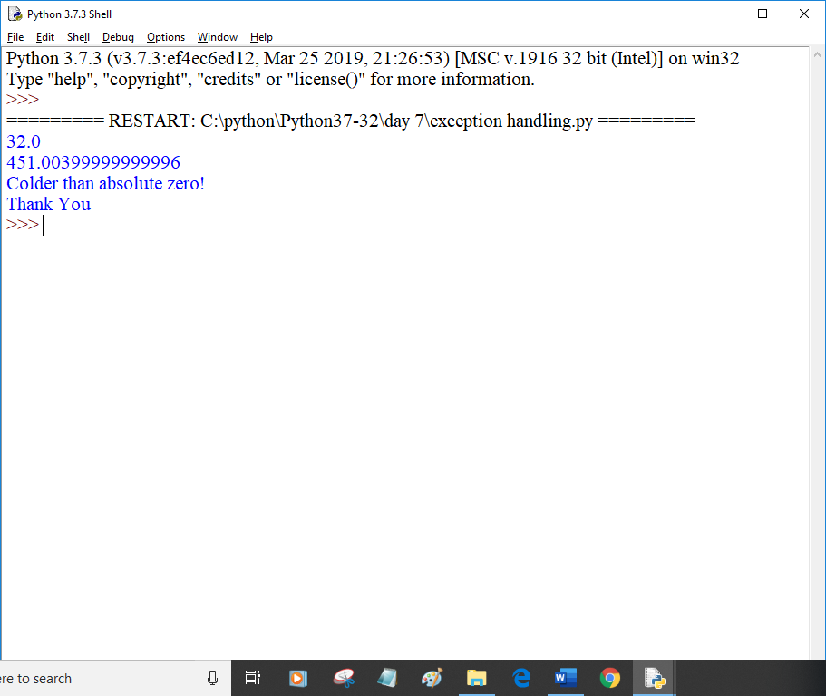

def div(a,b):

assert(b!=0),"Division by zero is not defined"

return a/b

try:

print(div(20,3))

print(div(100,20))

print(div(55,0))

except AssertionError as ob:

print(ob)

